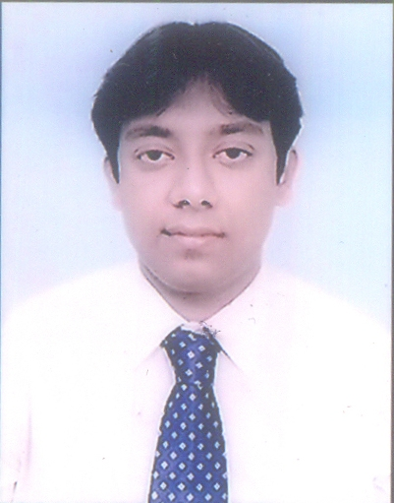

Name: DEEPANJAN DEY.

PERSONAL DETAILS CONTACT DETAILS
Sex: Male 9831858562 (Mobile),03324489640(Landline)
Date of Birth: 26/10/1989 Present Address: 31,Durgapore Lane
Email:deydeepanjan7@gmail.com PO-Alipore PS-Chetla
Kolkata-700027
Nationality: Indian Permanent Address: 31,Durgapore Lane
PO-Alipore PS-Chetla
Kolkata-700027

Area of Specialization: MBA ( Marketing - major & Finance  minor)

Career Objective: To be a part of an organization where I can utilize & grow my qualities.

EDUCATIONAL QUALIFICATIONS ~

Examination | Year of passing | Institution | Board/University | CGPA/  Percentage
Master of Business  Adminstration | 2013 | Institute of Business Management & Research,Kolkata | West Bengal University of Technology | 7.35
Graduation (B.Com Honours) | 2010 | Heramba Chandra College | University of Calcutta | 51%
Indian School Certificate Examination | 2007 | St. Joseph & Marys School | Council For The Indian School Certificate Examination | 65%
All India Secondary School Examination | 2005 | Bodhicharya Senior Secondary School | Central Board of Secondary Examination | 64%

OTHER PROFESSIONAL QUALIFICATIONS ~

Name of the organization | Duration | Course / Focused on
Hazra Youth Computer Training Centre | July,2008  to  June,2009 | Diploma in Financial Accounting
Infocus Education | 03.09.2011  to  06.11.2011 | ERP course on SD module
British Council | _ | BEC Preliminary

WORK EXPERIENCE ~1) Have done two months of summer internship at TVS Motors Company Ltd.
2) Have nine months of experience in real estate marketing at ICICI Home Finance Company Ltd.
3) Have seven months of experience at Ultrapure Technology & Appliances India Ltd. in their modular kitchen department as Sales Executive.
4)Have 1 year 8 months of experience at Matrimony.com ltd as Executive - Assisted Service.
5)Currently working at Magicbricks Realty Services Limited(Times Group) as Account Manager.

LINGUISTIC PROFICIENCY ~

Language | Read | Write | Speak
English | Yes | Yes | Yes
Bengali | Yes | Yes | Yes
Hindi | Yes | Yes | Yes

ACTIVITIES AND INTERESTS: Playing Table Tennis & Cricket,riding bicycle &
Travelling.

Declaration:
I hereby declare that the above mentioned information is correct up to best of my knowledge and I bear the responsibility for the correctness of the mentioned particulars.

Date:15/07/2016 DEEPANJAN DEY
(Signature)

